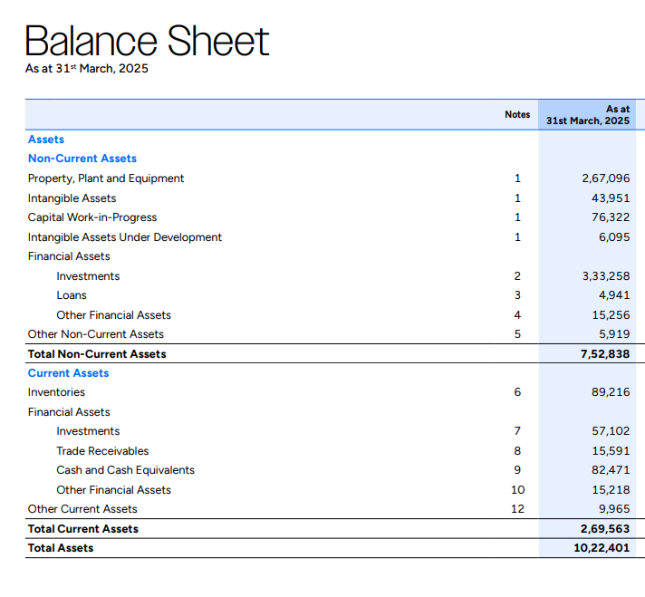
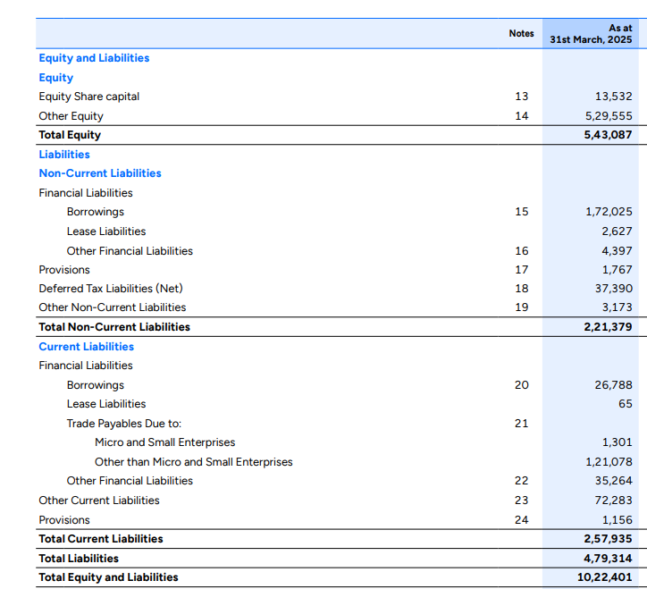
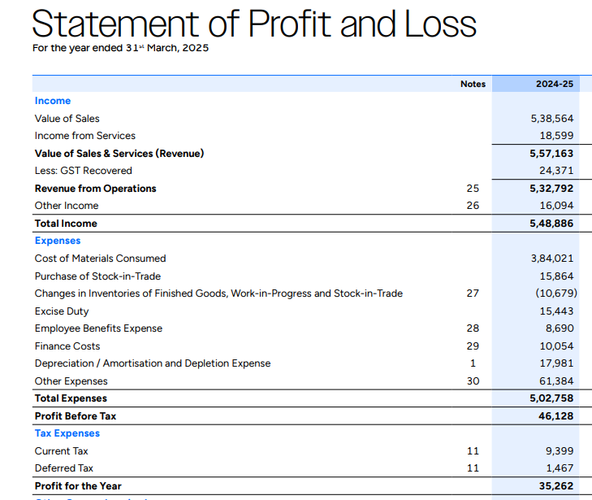

Additional Information:
Manufacturing Expenses worth 43003 crores are included in other expenses.
In Revenue from Operation 60% was on credit and 40% cash
In purchase of material and Stock in trade 70% was on credit and 30% in cash

Calculate following ratios:
Current Ratio: $\text{Current Ratio}=\frac{\text{Current Assets}}{\text{Current Liabilities}}$
Quick Ratio (Acid Test Ratio): $\text{Quick Ratio}=\frac{\text{Current Assets}-\text{Inventories}\text{-Prepaid Expenses}}{\text{Current Liabilities}}$
Debt-Equity Ratio: $\text{Debt–Equity Ratio}=\frac{\text{Debt}}{\text{Shareholders’ Equity}}$
Total Debt-Equity Ratio: Total $\text{Debt–Equity Ratio}=\frac{\text{Total Debt}}{\text{Shareholders’ Equity}}$
Interest Coverage Ratio: $\text{Interest Coverage}=\frac{\text{EBIT}}{\text{Finance Cost}}$
Proprietary Ratio: $\text{Proprietary Ratio}=\frac{\text{Shareholders’ Equity}}{\text{Total Assets}}$*100
Debt-to-Asset Ratio: $\text{Debt-to-Asset Ratio}=\frac{\text{Total Debt}}{\text{Total Assets}}$*100
Return on Capital Employed (ROCE)
$$ROCE=\frac{EBIT}{ Capital Employed}*100$$
Capital Employed=Total Assets−Current Liabilities

Return on Equity (ROE)
$$ROE=\frac{Profit After Tax}{Shareholders^{'} Equity}*100$$
Return on Assets (ROA)

$$ROA=\frac{Profit After Tax}{Total Assets}*100$$
Inventory Turnover Ratio
$$Inventory Turnover=\frac{COGS}{Average Inventory}$$
COGS= Cost of Materials Consumed + Purchase of Stock-in-Trade plus Change in Inventory + Manufacturing Expenses

Trade Receivables Turnover
$$Receivable Turnover=\frac{Net Credit Revenue}{Average Trade Receivables}$$
Trade Payables Turnover
$$Payables Turnover=\frac{Credit Purchase}{Average Payables}$$
Fixed Asset Turnover
$$FAT=\frac{Revenue}{Net Fixed Assets}$$
Total Asset Turnover
$$TAT=\frac{Revenue}{Total Assets}$$
Also compute Gross Margin, Net Margin and Operating Margin

